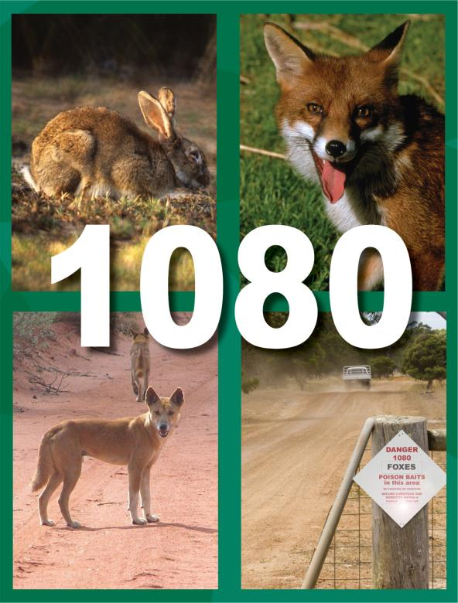

Safe use and management of 1080
Landholders manual

Copies of this publication can be obtained from the Department of Agriculture and Food, Western Australia website: Baiting and poison permits atagric.wa.gov.au/baiting-applicationsor by contacting the department at:
3 Baron-Hay Court, South Perth, Western Australia 6151, Australia
Postal Address: Locked Bag 4, Bentley Delivery Centre WA 6983
Phone: +61 (0)8 9368 3333 Fax: +61 (0)8 9368 2958

IMPORTANT DISCLAIMER
The Chief Executive Officer of the Department of Agriculture and Food, Western Australia and the State of Western Australia and their officers, employees and agents will not be liable, in negligence or otherwise, to any person for any loss, liability or damage arising out of an act or failure to act by any person in using, relying on or disseminating any information, representation or statements contained in this publication.
Mention of trade names does not imply endorsement by the department over any other equivalent product from another manufacturer. Any omission of a trade name is unintentional. Recommendations were valid at the time of printing.
© Western Australian Agriculture Authority, 2016

Preface
Individuals planning to conduct a 1080 baiting program must have a permit to use 1080 bait products in Western Australia. A person must complete training and an assessment to become an approved user.The authorisation is granted as a permit following an assessment based on training on how to use and manage 1080 safely. This document contains the information required for the training and assessment.
Training and assessment requirements for Licensed Pest Management Technicians (LPMTs) are separate. These are provided by the Department of Health.
Training for the use of 1080 is best undertaken on-line. If required, a DAFWA biosecurity officer can arrange a written assessment. Please note that Permit holders must be over 18 years of age
This document provides information for Western Australian landholders regarding:
- the legislated requirements for the use of 1080 in Western Australia (WA)
- personal safety, identifying signs of poisoning and applying appropriate first aid treatment
- how to obtain a permit to use 1080 on your property
- how to safely store and transport 1080
- the procedures and notification required to carry out a baiting program
- your responsibilities for notifying of any accidents or incidents
- methods for evaluating the success of a baiting program

I remind that the primary purpose for undertaking risk assessments and issuing permits for Restricted Chemical Products (RCP’s), including for 1080 is to ensure safe use and long-term availability of the toxins and methods used for invasive species control in WA.
Access to online training for approved users can be requested by email from biotraining@agric.wa.gov.au.
For information about requirements to become an approved user, or to apply for a permit for the use of 1080 products, contact is by email: ISPermit@agric.wa.gov.au()
Viv Read
Director Invasive Species
July 2016

Table of contents
1. Introduction 1
1.1. Purpose of the ‘Safe Use and Management of 1080’ manual 1
2. Legislation and regulations 2
3. Authorisation for the use of 1080 bait products 2
3.1. Requirements 3
4. Using 1080 bait products 4
4.1. Placement of baits 4
4.2. Preparing a Permit application 5
4.3. Requirements for record keeping 8
4.4. Purchasing 1080 animal bait products 8
4.5. Transport of 1080 bait products 9
4.6. Storage of 1080 baits 9
4.7. Preparation and laying of baits 10
4.8. Notification and warning signs 11
4.9. Reducing potential harm to non-target animals 12
4.10. Restrain pets, exclude livestock and unauthorised persons 13
4.11. Replace baits and dispose of poisoned carcasses 13
5. Biodegradation of 1080 14
6. Use of Canid Pest Ejectors 14
7. Completing the Baiting Program 15
7.1. Comply with target dates authorised by the permit 15
7.2. Dispose of carcasses, unused baits and bait containers 15
7.3. Evaluate the success of the baiting program 15
8. Personal safety 16
8.1. Personal protective equipment 17
8.2. Additional precautions 18
8.3. Recognise the symptoms of 1080 poisoning 18
8.4. First aid for 1080 poisoning 18
9. Important points to remember 19
10. Conclusion 19
11. Further reading 20
Appendix 1: Sample assessment questions 21
Appendix 2: Restricted Chemical Product (RCP) 22
Appendix 3: Mapping areas for a 1080 baiting program. 24
Appendix 4: Template letter for notifying neighbours of intention to use 1080. 25
Appendix 5: Warning sign template 27
Appendix 6: 1080 – Characteristics and use 28

Landholders safe use and management of 1080

Introduction
The product ‘1080’ (Sodium fluoroacetate) is a toxin developed to control declared pest animals such as rabbits, foxes, wild dogs and feral pigs. However its use to control these pest animals poses a risk to humans, pet animals and other non-target species. Therefore 1080 use in Australia is closely regulated by Commonwealth and State government agencies.
The ‘Code of practice for the safe use and management of 1080 in Western Australia’(the Code) sets out the legal requirements for the safe management and use of 1080 products including training, risk assessment, issue of permits and audits of landholders.
In many instances, 1080-based control programs are the only viable strategies available for broad acre control of declared vertebrate pests andwithwell-planned and applied baiting programs, rapid effective knockdown can be achieved. To ensure there is on-going access to this toxin by landholders and to prevent the risk to the public and domestic pets by use of this toxin, it is imperative that a high level of responsibility for its use is adopted.Bait users should always manage the risks associated with their particular baiting activity appropriately to ensure the safe and effective use of 1080 baits for pest control.

Purpose of the ‘Safe Use and Management of 1080’ manual
This manual describes the minimum standards that apply to 1080 pest animal bait use in Western Australia. The information contained in this manual is relevant to the training required by individuals intending to obtain authorisation to use 1080 as part of a vertebrate pestcontrol program.

The purpose of this document is to provide the landholder with a clear understanding of their responsibilities in the use of ‘1080’ for the control of pest animals particularly if they want to obtain a permit for safe use of this product.

Legislation and regulations
1080 is considered as a ‘dangerous poison’ by the Department of Health (Schedule 7) and is defined as a Restricted Chemical Product.
The Poisons Act 1964 and associated Poisons Regulations 1965 are the primary legislation that addresses the manufacture, sale, use and possession of 1080 in WA.
Poisons (Section 24) (Registered Pesticide 1080) Notice 2000 (and Variation Notice 2001) restricts general access to 1080 as a Schedule 7 (S7) poison and is therefore only available from retailers licensed to sell S7 poison products.
1080 baits used by DAFWA and the Department of Parks and Wildlife (DPW) have been approved for use by the Australian Pesticides and Veterinary Medicines Authority and are used according to the label or research permit requirement and The Code in Western Australia.
The use of vertebrate pesticides in WA must be in strict accordance with label directions for use supplied with each product.
The Code provides the intent of the legislation and elaborates on the procedures for training and the handling of 1080 products. A copy of the Code is available from Western Australia’s Department of Health website: ww2.health.wa.gov.au/Articles/F_I/Hazardous-chemicals.

Authorisationfor the use of 1080 bait products
Alandholder, a person or staff operating as a commercial pest controller orundertaking environmental or agricultural pest control can become an authorised personfor the supply and use of 1080 animal pest bait products in Western Australia. This requires successfullycompleting training on the safe use and management of 1080.
Landholders, property managers of their agents can complete the assessment online in the form of the ‘Safe use and management of 1080’ course. Contact DAFWA (biotraining@agric.wa.gov.au) for more information. Recognition of your training may be revoked at any time you are found to be non-compliant with the Code of Practice, or you fail to demonstrate appropriate knowledge of safe use and handling principles.
The preferred option is for the assessment to be undertaken on-line. Alternatively, you may complete a written assessment available from DAFWA. The assessment consists of 20 multiple choice and true/false questions. All the questions are based on the information contained in this document.
A sample of an assessment questionnaire is found in Appendix 1.

Requirements
To conduct a 1080 baiting program the owner, landholder or manager of the property must apply for a permit to DAFWA (Appendix 2). Application forms to obtain permits for restricted chemical productsare available from the DAFWA website (agric.wa.gov.au/baiting-applications).
To obtain a permit, a person must:

Demonstrate a thorough knowledge of using and managing 1080 products.
By completing the online course and assessment, or alternatively by undertaking a written assessment provided by DAFWA.

Submit a permit application form
The application must include:
- Full name and address details of the applicant
- target species (more than one may be nominated)
- 1080 bait product name andquantity required
- proposed start and end date of intended baiting program/s
- name and address of the S7 retailer where products will be purchased
- the names and addresses of person/s you nominate as agents to receive bait products on your behalf from the retailer
- the names and addresses of person/s you nominate to lay the baits*.
*All must be appropriately trained or licensed to use 1080 pest bait products
Refer toApplication forms to obtain permits for restricted chemical products from DAFWA website agric.wa.gov.au/baiting-applications
For specific information on using 1080 to control rabbits, foxes, wild dogs or feral pigs, or any additional information regarding 1080, please contact a DAFWA biosecurity officer.

Produce a map of the proposed 1080 baiting program with the application form
Ascaled hand drawn map, a computer digitised map or an aerial photograph (with labelled features) should clearly show baitingdetails in order to obtain a permit to possess and use 1080 products (see example Appendix 3).

The map must clearly identify
a) Proposed locations and features
- Baiting zones.It is agood management practice to identify on your map the general area where 1080 products are likely to be laid.
- Bait exclusion zones. Mark areas not to be baited, including areas posing a potential risk to human and non-target species poisoning(for example, around buildings, bush remnants and water courses etc.). Refer to (section) restrictions
- Disposal site. The location where poisoned animal carcasses, used 1080 containers and excess baits are to be buried or burned.
- Location of warning signs. Mustbe prominently displayed at all property entrances and other strategic points.
b) Existing features
- Roads and tracks: include the tracks used to access baiting sites.
- Location of dwellings and constructed recreational sites. Identify dwellings and constructed recreational sites on your property and those on adjacent properties.
- Property access points and boundaries: include those used for public use and management use.
- Water bodies and water courses.
- Significant areas of bush/scrub.
Note: the map should include a map scale or estimated distances between the baits and local features such as bush areas, dwellings, recreational areas, water bodies etc.A sample of a map for a proposed baiting program is available in Appendix 3.

Using 1080 bait products

Placement of baits

Bait exclusion zones
To help manage the potential risk of poisoning non-target species, including humans, domestic pets, livestockand native animals there are distance restrictions for the placement of 1080 baits.Under the code, the following minimum restrictions are specified:

a) For ground baiting programs, 1080 baits must be placed no closer than:
- 150m from a dwelling
- 20m from permanent or flowing water bodies
- 5m from boundary fences, and
- 20m from the edge of formed/gazetted public roadways,
or as directed by the authorising officer.
b) For aerial baiting programs, 1080 baits must be dropped no closer than:
- 150mfrom a dwelling
- 20m from permanent or flowing water bodies
- 500m from all property boundaries and constructed recreation sites, and
- 250m from the edge of formed/gazetted public roadways,
or as directed by the authorising officer.

1080 in water catchments
The laying of baits in water catchments is subject to the legislation and restrictions that protect PublicDrinking Water Source Areas (PDWSA). PDWSA are categorised as P1, P2 or P3. Reservoir ProtectionZones (RPZs) are also protected under legislation, which is designed to protect water sources from contaminationby preventing access.
The restrictions are summarised as follows:
- Reservoir protection zones: no baiting within 2km of the top water level of a reservoir.
- P1 PDWSA: no baiting within 500m of a bore or wellhead.
- P2, P3 PDWSA: no baiting within 300m of a bore or wellhead.
- The authorising officer will impose the relevant conditions on permits for those properties affected.

Preparing a Permit application
The application forms for the use of Restricted Chemical Permits (RCP) is available from DAFWA website from agric.wa.gov.au/baitingpermits. A sample of such application is available in Appendix 2.

Risk assessment of a 1080 program
Once your application form is submitted, DAFWA will assessif it is safe (that is, a manageable risk) to use 1080 as proposed on the property.

There are three risk categories associated with the risk assessment:
- Manageable risk: where 1080 bait can be used in accordance with the directions for use with no additional permit conditions or where some potential risk may occur but this can be overcome with additional permit conditions.
- Extreme risk: where approval to bait is refused because the use of 1080 is likely to pose an unacceptable risk which cannot be adequately managed with additional permit conditions.

Verification of minimal distances are respected
The authorising officer may vary the above distance restrictions for both ground and aerial baiting, providedthat the varied distance restrictions would not increase the risk to public safety, and/or non-targetspecies.
The distance restrictions that apply may vary according to the type of bait being used, the target species (for example, meat baits/grain baits) and the method of baiting (for example, aerial or ground baiting).
The 'Directions for use' supplied with the 1080 product will clearly explain the minimum distances that the specific bait type is allowed to be placed away from property boundaries, constructed recreational sites, dwellings, gazetted public roads and permanent or flowing water bodies.
The 'Directions for use' will also stipulate how long the baits should be left undisturbed (if applicable) and how many days of fine weather should be forecast for the baiting period, as rain can reduce the effectiveness of the baits.
DAFWA may impose additional restrictions on your baiting program. These additionalconditions will be clearly set out on the permit issued by DAFWA. An example maybe "No baits are to be laid within 50m of the boundary fence adjacent to the public golf course".

Issuing permits for the use of 1080 products
If your baiting application is approved, DAFWA will issue you a restricted chemical product permit. The permit will identify:
- its unique number
- the period of validity (may be up to five years in some areas)
- the nominated retailer's details
- the approved baiting period/s
- the species to be controlled
- the product and quantity of 1080 products that can be dispensed during a specified timeframe
- the names and addresses of the nominated receivers
- the names and addresses of the nominated approved users
- and any additional baiting conditions and restrictions deemed necessary.
DAFWA may impose additional conditions such as erecting additional signage or not baitingclose to areas that are frequented by the public.
DAFWA will provide a copy of the permit to your nominated retailer. The retailer is thenrequired to issue products in accordance with the permit.
The issue of 1080 products remains restricted and products can only be accessed as specified on the permit.

Amending or renewing permits
DAFWA may amend the restricted chemical product permit if you wish to:
- change nominated retailer
- add or change approved users
- add or change nominated receivers
- amend nominated baiting periods
- amend baiting map
- amend bait product amount or supply interval.

The permit will be cancelled and a new permit issued for changes to the applicant, target species, nominated product or extension to the permit.
Please note that fees apply to permit applications and amendments to permits.
The April 2012 Code of Practice contains provision for a risk assessment and approval to remain validfor up to five years, provided there are no changes to the property that affect the level of risk. Those applications from areas other than the rangelands where surrounding landuse changes may occur more regularly may only be granted shorter term permits.
If the owner/occupier of the land changes or the land use changes, a new risk assessment and permit will be required.

When permits will not be supplied
Approval for baiting will NOT be given to:
- persons under 18 years of age
- people who live in urban areas or on small properties in areas where the use of 1080 baits poses an unacceptably high risk
- landholders in areas zoned ‘Special Rural’, unless your baiting operation forms part of a coordinated community-based control program, or where declared pest animals are causing serious economic damage that cannot be controlled by other means
- landholders where there is an unacceptable risk associated with transporting, storing or the handling of 1080 baits.
Where baits cannot be issued directly to a landholder, they may be laid under contract (for example, licensed pest control operator,) in some circumstances, or alternative control measures may be suggested.

Applicant responsibilities:
It is the responsibility of the applicant to advise DAFWA of any changes to property owners, occupiers, land use, surrounding land use or other permit details.
Nominated users must have received the appropriate training for using or managing 1080 correctly and safely to be listed on the permit.

Requirements for record keeping
All persons dealing with 1080 products must keep records of the storage, transfer and use of 1080 products unless otherwise exempted by the DG, DOH. Records must:
- include all 1080 products,
- include details of receipt from, and consignment to, Licensed wholesalers, Licensed retailers, Licensed Pest Management Technicians and Approved Users
- include a register of all 1080 products stored, and
- be kept for a minimum of two years from the date of supply.
Records to show transfer between authorised people, which are to contain the Authorised Department’s Permit identification number, must be retained for all transactions of 1080 and be signed by the issuer and receiver.

Purchasing 1080 animal bait products
1080 bait products may only be supplied by authorised retailers or wholesalers to authorised persons.
When you lodge your permit application, you are required to nominate the S7 retailerwho will supplyyour 1080 products. A copy ofthe permit is issued to the retailer so that you do not needto arrange to have the original permit shown every time a person whom you have nominated to receive (that is, collect) products on your behalf visits the retailer to collect your products.
As per the permit, the nominated receivers must take personal identification to the nominated S7 retailerto purchase specified 1080 products.
The retailer may issue up to the prescribed amount of the nominated product within the supply intervalidentified on the permit.
For example
A permit valid for 12 months allows for 200 dried meat baits to be issued every 13 weeks (three months) – a maximum of 800 baits for the duration of the permit.
A receiver may collect 200 baits at one visit but will not be issued any more until the initial three month period has passed; or
A receiver may collect 100 baits at one visit, and collect a further 100 at another visit within the same three month period.
It is an offence for someone other than a person nominated as a receiver on the permit to purchase or pick up baits from the S7 retailer.

Transport of 1080 bait products
1080 bait products must be transported in accordance to the Code:
- 1080 products must be transported in a locked container in a securedpart of the vehicle.
- 1080 must never be transported with foodstuffs.
- Vehicles carrying baits should not be left unattended.
- Domestic animals should be segregated from the baits.
- 1080 should be segregated from any passengers and the driver of the vehicle.
Carrying baits in a small locked toolbox inside an anchored and locked tool-chest on a utility would be anideal transportation method.

Storage of 1080 baits
The storage of 1080 products must adhere to the Code specifications. They must be always stored in their original packaging in a double locked container exceptwhen they are required for immediate use. 1080 products must always be kept in areas inaccessible tothe public and must not be stored with foodstuffs.
Depending on the 1080 product the following types of storage can be used:
- designated, marked poison cupboard
- chained and padlocked in a locked security store
- locked freezer
- locked cupboard.
All storage areas must comply with the dangerous goods regulations for storage safety, security andwarning signs. Material Safety Data Sheets are also required to be kept with all poisons stored.

Preparation and layingof baits
Remember, you must ensure appropriate:
- personal protective equipment is worn
- methods of laying bait and the rate of lay to be used
- bait placement and location (consistent with restrictions)
- disposal of carcasses, unused products, used containers.
It is an offence to use a 1080 product contrary to the product label, directions for use and Code of Practice. You must also comply with any additional instructions given by DAFWA that are contained on the permit.

Hints for reducing potential risks to non-target species
- Where suitable, lightly cover dried meat baits with soil or tethering baits. This may help to prevent birds or other non-target species from finding, consuming or moving baits.
- Where possible, time baiting to occur outside of native animal breeding seasons or during periods of food shortage.
- Do not lay oat baits in bush or close to native vegetation remnants.
- Consider using scatter-baiting to make the grain baits less visible and more difficult for native animals to find and consume.
- When water birds are present, do not lay grain baits near dams or water courses, or their feeding areas.
- Minimise the potential risk of secondary poisoning of non-target animals by disposing of poisoned carcasses on a regular basis during baiting programs.

Notification and warning signs

Notify your neighbours of your intention to lay 1080 baits
Notice must be given in writing or other approved method at least 72 hours prior the date starting your 1080 bait program (but not more than 14 days’ notice). This notice must include:
- period of baiting
- address of property where baits are to be laid
- type of bait intended to be used.
Note: We recommend the use of the template letter included in this manual to notify your neighbours of your intention to use 1080 (Appendix 4).

Erect prominent warning signs indicating that 1080 baiting is taking place
Warning signs must be displayed during the baiting period and for at least one month afterwards. Signs must be erected on the property being baited at all entrances and other strategic points, (for example, vicinity of the baits and fence posts).

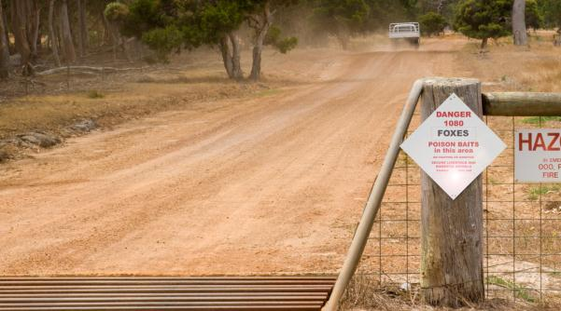
Warning signs must be erected to alert the public that 1080 baiting is taking place.

1080 Warning signs
Approved user musterect prominent warning signs at entrances and strategic points on the property to be baited alerting the public that 1080 baiting is taking place.
Warning signs must comply with 1080 product label specifications and mustinclude specified information listed (see Appendix 5). For example
- date baits laid
- contact telephone number of authorised user and/or layer
- toxin name ie:1080 and or Strychnine
- target animal(s) and a warning that domestic animals and pets can be affected and
- a “no- shooting or trapping” statement.
Approved users mustmaintain warning signs for four weeks longerthan the duration of the operation.or until all untaken baits are recovered.
In the case of ongoing baiting operations that are carried out on a continuing basis, warning signs must state that baiting occurs on an ongoing basis.

Reducing potential harm to non-target animals
There is a wide variation in the sensitivity of the different animal families and between species to 1080 depending on the rates species process 1080. Canids (dogs and foxes) are among the most sensitive; herbivores and birds are less sensitive; and reptiles and amphibians are relatively insensitive to 1080.
Fish and other aquatic fauna (including many invertebrates) are relatively resistant to 1080, and lethal concentrations would not be achieved even under intensive, standard aerial baiting programs. Also, 1080 is removed from baits fairly rapidly under moist conditions through leaching and microbial action.
The toxicity of 1080 can increase when animals are exposed to temperatures outside of their normal body temperature range.
1080 can have a chronic effect (that is, effects caused by a sub-lethal dose) on a number of species, such as a temporary reduction in their fertility. It does not cause genetic changes to organisms.

Sensitivity of native animals
Many native animals in WA are quite tolerant to 1080 because they have co-evolved with 1080-bearing plants. These animals can generally eat some plants or animals containing 1080 with little risk of being poisoned. The same species of animals in south-eastern Australia, where the toxic plants do not occur, are generally much more sensitive to 1080.

Sensitivity of introduced animals
Introduced pest species such as wild dogs, foxes, rabbits, feral cats and feral pigs have higher levels of sensitivity to 1080 than the adapted native species from WA.

Sensitivity of pets and livestock
Most pets and domestic stock are also introduced species and are highly sensitive to 1080, so they are susceptible to 1080 baits. Livestock and pets are at risk of death if they feed on the bait trails of 1080 oats used to control rabbits or if they consume recently poisoned carcases.
Dogs are at risk from both eating baits and through secondary poisoning. Secondary poisoning occurs when animals feed on poisoned carcasses (such as rabbits killed by 1080 baits). Such carcasses may remain toxic until they decompose. This poses little risk to native fauna, due to their enhanced tolerance to 1080.

Restrain pets, exclude livestock and unauthorised persons
Throughout the baiting process you must ensure that unauthorised persons (such as children and tourists) are not able to gain access to the baited areas. It is important to ensure that warning signs advising that 1080 baiting is in progress, are placed in prominent places and entry points.
Ensure that pets are restrained during the baiting program (consider muzzling working dogs to prevent them eating baits if they are required to work within baited areas) and ensure that livestock do not have access to bait. Exclusion fences can be used to keep livestock away from bait trails, and risks to livestock can be minimised by placing bait stations and Canine Pest Ejectors in areas where livestock are unlikely to access.

Replace baits and dispose of poisoned carcasses
In some cases (for example, for fox baiting) it may be advisable to not lay out all baits at once.(i.e.: Recommended rate of lay for fox baiting = 5 baits per 100ha or 5 baits per km2) Where practical, the baited area should be checked every day and any baits that have been taken should be replaced. This allows you to place the baits in the areas that are most likely to be taken.
Carcasses of 1080 poisoned animals are often difficult to find, but any that are found must be disposed of as specified inthis manual (for example, burial or burning).

Biodegradation of 1080
Loss and degradation of 1080 from baits and carcasses is mainly dependent upon leaching, and the action of microorganisms.
Being highly water soluble, 1080 is readily leached from baits into the soil in the presence of rain or even heavy dew. 1080 baits that are exposed to rain will become less toxic ('sub-lethal') as the poison is leached away into the soil. Therefore baiting programs should be suspended during periods of wet weather as sub-lethal doses may result in the pest becoming bait shy.
Most 1080 is eliminated from living animals within three days. If an animal ingests a sub-lethal dose of 1080, toxin residues will not persist in meat, blood, the liver, or fat. This is in contrast to most anticoagulants (for example, brodifacoum, bromadiolone) and many other pesticides.
Upon contact with soil a number of fungi and bacteria degrade 1080 into harmless by-products, preventing 1080 from accumulating in or contaminating the environment.
In general, meat baits are usually more impervious to water than grain-based 1080 products. However, all 1080 baits that are exposed to rain can become non-toxic or sub-lethal.
Therefore, baiting programs should be suspended during periods of wet weather.

Use of Canid Pest Ejectors
Canid Pest Ejectors (CPEs) are a new method of deploying 1080 to wild canids (foxes and wild dogs). CPEs consist of a spring powered piston which is mounted in a metal tube which is inserted in the ground. A lure head (comprised of dry meat and a 1080 poison capsule) is attached to the top of the tube, protruding from the ground. When triggered, by the lure head being pulled firmly upwards, the piston fires, spraying 1080 from the bait capsule into the canid’s mouth.
Advantages of CPEs are that they have greater target specificity than conventional meat baits as deployment of 1080 is conditional on upwards pulling which is easily achieved by canids, but less so by non-target species. CPEs are also fixed in place so cannot be moved or cached by animals. The 1080 capsules used in CPEs are sealed and protected from the elements and can consequently be left in place for extended periods, unlike conventional dried meat baits where the 1080 degrades over time.
Capsules are available in 3mg and 6mg of 1080 for foxes and wild dogs respectively which is the same rate as current commercial bait products for these species.
Risks to human health associated with CPE capsules are similar to those associated with the use of 1080 dried meat baits.
Currently authorised 1080 users are able to access and use these devices in accordance with current 1080 legislation and the Code of Practice. Authorised users who intend to use these devices or wanting to obtain information on this product should familiarise themselves by accessing the manufacturers handbookavailable from Animal Control Technologies (Australia) Pty Ltd website at animalcontrol.com.au/pdf/ACTA_CPE_DL_Booklet.pdf; and watchingPestSmart–Invasive animals CRC’s training videoon Mechanical Ejectors for wild dog and fox controlat youtube.com/watch?v=6Tdq7FKxeO8 .

Completing the Baiting Program

Comply with target dates authorised by the permit
Ensure the baiting program is completed by the completion date stated on the permit.Remember,

It is an offence to bait outside the approved baiting periods.

Dispose of carcasses, unused baits and bait containers
Check for any poisoned carcasses for 14 days after the completion of baiting.
Unused baits must be disposed of at the completion of the baiting program.
It is an offence to keep baits for future use or to sell or give baits to any other person.
Please refer to Section 4.11.Replacement baits and disposal of poisoned carcasses. Thisexplains how to manageand dispose of un-used baits, carcasses and used containers (usually through deep-burial or burning).

Evaluate the success of the baiting program
It is important to ascertain the effectiveness of the baiting program. The evaluation should determine the effect on the target species population (including damage caused by the target species) as well as any effect on non-target species.
Animals killed by 1080 are not usually found. This is because of the relatively long lag time between consumption of bait material and the onset of signs of poisoning. Failure to find any carcasses does not mean that the baiting has not been effective.

Methods of evaluation may include:
- evaluation of the number of baits taken
- reduction in damage caused by the target (for example, lambs killed)
- reduction in the numbers of the target animal seen
- reductions in signs of the target animals (for example, digging or footprints)
- increased activity or density of native fauna.

Discuss control options with your biosecurity officer.

1080 can be a very effective control method for rabbits, foxes, wild dogs and feral pigs.
Alternative methods of control are available depending on the target species. Although not always suitable, alternative control methods may include:
- ripping of warrens/dens
- trapping
- shooting
- exclusion fencing
- fumigation.
Often an integrated pest management approach using one or more of these methods is most effective, particularly when you include your neighbours in a broad-scale baiting program.
Community baiting
Your regional biosecurity group can help you to implement a community program, where neighbouring properties agree to undertake control programs at the same time. This combined effort can often achieve a significant reduction in the target species and a longer-term effect on a landscape scale.Contact DAFWA if there is not biosecurity group formed for your area.

Personal safety
1080 is extremely toxic to humans and there is no effective antidote – less than 0.35g of pure 1080 has the potential to kill most adults.
A complete commitment to the safe use of 1080 is essential.

Personal protective equipment

The protective equipment required may differ according to the 1080 product you are handling.
As a guide, when handling dry formulations of 1080 (such as dried meat baits or oat bait) you should wear:
- chemically impervious gloves (for example, PVC or Nitrile)
- protective clothing (for example, overalls)
- safety glasses or goggles (for oat dust)
- when using liquid forms of 1080 such as capsules for Canine Pest Ejectors (CPE’s)
- wear elbow-length chemical-resistant gloves (for example, PVC or Nitrile) and after each days use, wash gloves and goggles
- dust mask for oat dust when using oat based rabbit products.
If product comes into direct contact with eye: hold eyes open, flood with water for at least 15 minutes and seek medical advice.
PVC or Nitrile gloves offer the best protection. Under no circumstances should household rubber gloves, leather gloves or cloth gloves be used as these types of gloves are not impervious to chemicals, and may absorb or accumulate the poison over time. Eye-wear can be used to reduce irritation from oat dust if necessary.

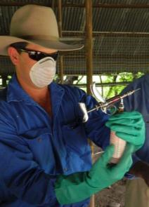
Protective clothing is necessary when dealing with 1080 baits

Additional precautions
Water should always be available whenever 1080 is being used. It can be used to wash down anyone that comes into contact with 1080 and for cleaning up after bait preparation and laying bait products.
Once you have finished handling or laying 1080 baits or products you should:
- thoroughly wash all equipment and surfaces
- remove protective clothing and wash (separately from other clothes)
- wash hands thoroughly with soap and water.
You must not eat, drink or smoke whilst 1080 is being handled.

Recognise the symptoms of 1080 poisoning
Recognising the signs of poisoning early can increase the chances of surviving 1080 poisoning. Symptoms include:
- intermittent convulsions
- increased sensitivity to external stimuli (for example, noise)
- irregular heartbeat
- nausea and/or vomiting
- failure to recognise people or familiar objects
- shaking.

First aid for 1080 poisoning
A careful rapid response to suspected 1080 poisoning is essential to enhance the patient's chances of survival.If poisoning occurs, immediately:
- Call 000 to request an ambulance.
- Call 13 11 26 for poisons information to obtain the current first aid advice.
- Remove any contaminated clothing from the patient.
- Wash any affected skin thoroughly through free flowing clean water.
- Do not induce vomiting or administer anything by mouth (there is a risk of choking).
- Place the patient into the recovery position to maintain their airway.
- If the patient stops breathing, only administer resuscitation if you can ensure that there is no risk to the rescuer of ingesting the poison from the patient (for example, through mouth to mouth contact). A suitable barrier mask should be used if applying resuscitation. Be aware that the patient may have involuntary muscle contractions.
- Reassure the patient and keep them calm.
- Wait for medical staff to arrive or if this is not possible take patient to doctor/hospital as soon as possible.
Make sure the 1080 product container, the ‘Safe Use and Management of 1080’ manual, and the Safety Data Sheet (SDS) are available to medical staff.

Important points to remember
Report any 1080 accidents and incidents immediately! You must report any accidents or incidents to DAFWA. Where human safety is at risk, the accident/incident must also be reported to the Police.
Accidents or incidents include (but are not limited to):
- spillage of 1080
- human exposure to 1080 and poisoning (Poisons Information Centre)
- theft or loss of 1080 products (DAFWA and Police)
- poisoning of non-target animals (DAFWA)
- use of 1080 contrary to permit conditions set by DAFWA.

Conclusion
If used properly, 1080 is a safe, efficient, effective and humane way of controlling rabbits, foxes, wild dogs, and feral pigs. However, you need to ensure that you use 1080 products in strict accordance with the ‘Safe Use and Management of 1080’ manual and the 'Code of Practice for the Safe Use and Management of 1080' so that 1080 products continue to be available in the future.
Do not take your responsibility lightly. You must take every precaution to ensure that the baits are used safely and do not end up in the wrong place or in the wrong hands.
The continued availability of 1080 as a control method for animal pests is vitally important to protect WA's agricultural and pastoral industries, and to maintain our unique biodiversity in WA.
Remember
- There is no effective antidote for 1080.
- Take every precaution to avoid ingesting 1080 products.
- Follow all recommended safety procedures for 1080 products.
- Assess the potential risk to non-target species prior to baiting.
- Inform your adjacent neighbours in writing prior to baiting.
- Adhere to all baiting restrictions and conditions given by the ‘Safe use and management of 1080’landholders manual and DAFWA.
- Do not lay baits outside of the designated area.
- Erect appropriate warning signs and leave in place for one month after baiting.
- Do not allow stock to eat 1080 products.
- Do not allow domestic dogs to eat dried meat baits or carcasses poisoned with 1080.
- Dispose of all un-used baits, poisoned carcasses (if any are found) and product containers.
- Do not sell or transfer 1080 products to any person.
- Do not store any 1080 product beyond the designated baiting period.
- Learn how to apply first aid in case of 1080 poisoning.
- Report any accidents or incidents involving 1080 products.

Further reading
Twigg LE and King DR (1991) The impact of fluoroacetate-bearing vegetation on native Australian fauna: A review. Oikos 61, 412-430.

Department of Health, DAFWA, Department of Environment and Conservation , 2012 Code of practice for the safe use and management of 1080 in Western Australia.(ww2.health.wa.gov.au/~/media/Files/Corporate/general documents/pesticides and chemicals/PDF/1080c/pesticides and chemicals/PDF/1080code.ashx).
Animal Control Technologies (Australia) Pty Ltd; Canid Pest Ejector- Controlling foxes & wild dogs(animalcontrol.com.au/pdf/ACTA_CPE_DL_Booklet.pdf).
PestSmart Invasive Species CRC; M44 Mechanical Ejectors for wild dog and fox control (video) (youtube.com/watch?v=6Tdq7FKxeO8).
Further information on 1080 is available from the DAFWA website (agric.wa.gov.au).

Appendix 1: Sample assessment questions
- Once you have finished handling 1080 baits you should:
  - Wash all equipment
  - Remove contaminated clothing for washing
  - Thoroughly wash hands with soap and water
  - All of the above
- Which of the following features is not required to be shown on your map (submitted with your restricted chemical product risk assessment and permit application form)?
  - Roads and tracks
  - Location of warning signs
  - Paddocks currently under crop or pasture
  - Dwellings and recreational sites
  - Property access points
  - Significant bush areas
- What must be provided to S7 retailers to enable a nominated person to be supplied with 1080 bait products?
  - Certificate of title proving their land ownership
  - Proof of identity
  - Original 1080 permit naming the person picking up the baits
  - National Police clearance
- How must empty 1080 containers be treated?
  - Returned to a S7 retailer for recycling.
  - Buried or burned and not re-used.
  - Labels should be removed before disposing of the containers in the usual methods with other normal household rubbish.
  - Containers that have been thoroughly washed may be re-used for other storage purposes.
- What action should be taken at the completion of a baiting program with bait material that has already been laid?
  - No action needs to be taken – the bait will eventually be taken by target species, or it will rain and make the baits non-toxic anyway.
  - Oat trails for rabbit baiting must be covered and dried meat baits for foxes and wild dogs collected and buried according to the ‘Directions for use’.
  - All the bait should be collected and returned to the S7 retailer.
  - If you intend to conduct another baiting program within 12 months, you should collect the un-eaten bait and store it for later use.

Appendix 2: Restricted Chemical Product (RCP)
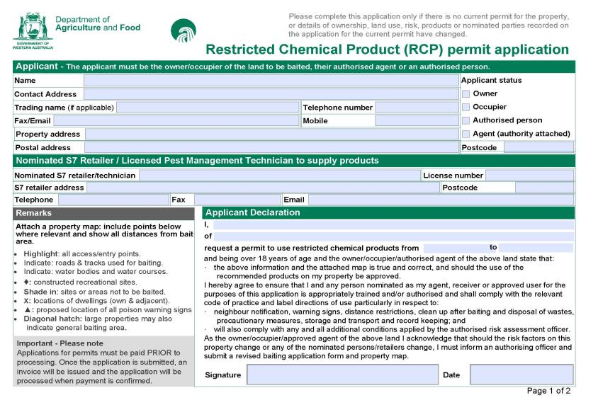Sample of the application for RCP permit (page 1)

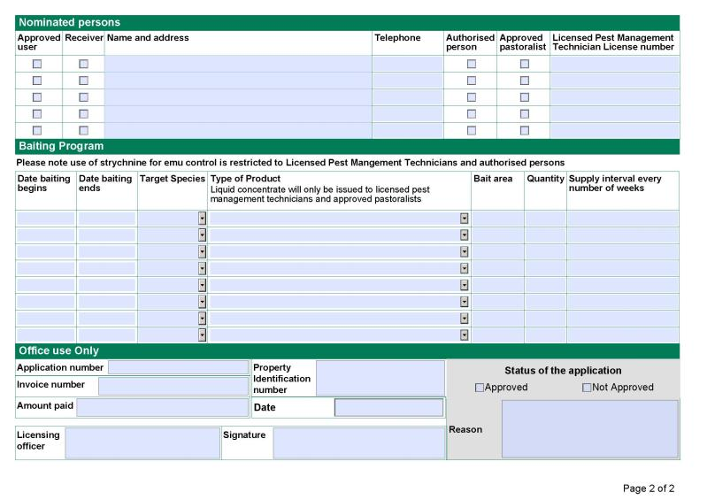
Sample of the application for RCP permit (page 2)

Appendix 3: Mappingareas fora 1080 baiting program.
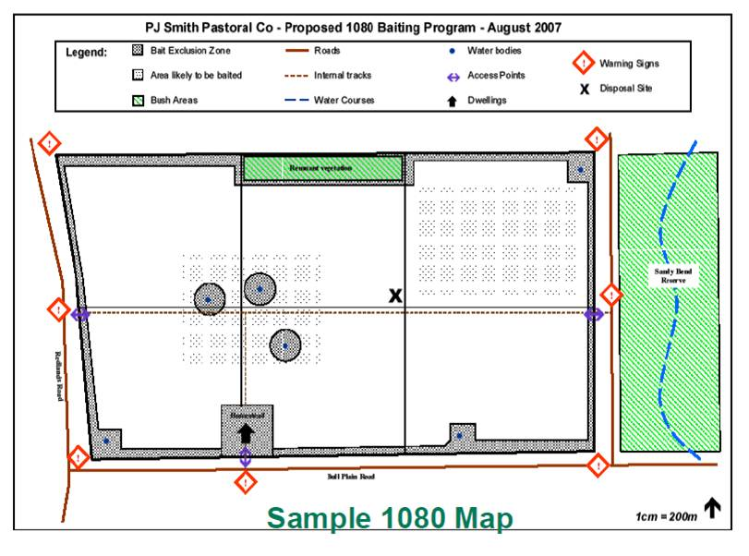
Example of a map to submit with your proposed 1080 baiting program.

Appendix 4: Template letter for notifying neighbours of intention to use 1080.
Copy and paste the text in the next page to prepare your notification letter.
Example:
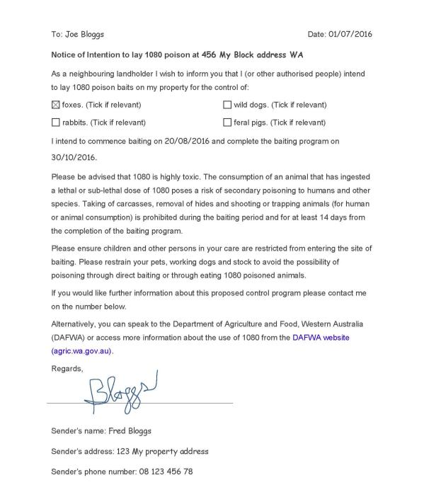

To: Click here to enter recipient’s name and address.Date: Click here to enter date.
Notice of Intention to lay 1080 poison at Click here to enter Address where poison is to be laid.
As a neighbouring landholder I wish to inform you that I (or other authorised people) intend to lay 1080 poison baits on my property for the control of:
foxes. (Tick if relevant) wild dogs. (Tick if relevant)
rabbits. (Tick if relevant) feral pigs. (Tick if relevant)
I intend to commence baiting on Click here to enter date and complete the baiting program on Click here to enter date.
Please be advised that 1080 is highly toxic. The consumption of an animal that has ingested a lethal or sub-lethal dose of 1080 poses a risk of secondary poisoning to humans and other species. Taking of carcasses, removal of hides and shooting or trapping animals (for human or animal consumption) is prohibited during the baiting period and for at least 14 days from the completion of the baiting program.
Please ensure children and other persons in your care are restricted from entering the site of baiting. Please restrain your pets, working dogs and stock to avoid the possibility of poisoning through direct baiting or through eating 1080 poisoned animals.
If you would like further information about this proposed control program please contact me on the number below.
Alternatively, you can speak to the Department of Agriculture and Food, Western Australia (DAFWA) or access more information about the use of 1080 from the DAFWA website(agric.wa.gov.au).
Regards,

Sender’s name: Click here to enter sender’s name.
Sender’s address: Click here to enter address.
Sender’s phone number: Click here to enter phone number.

Appendix 5: Warning sign template
This template can be transferred to another word document. Just select, copy and paste.
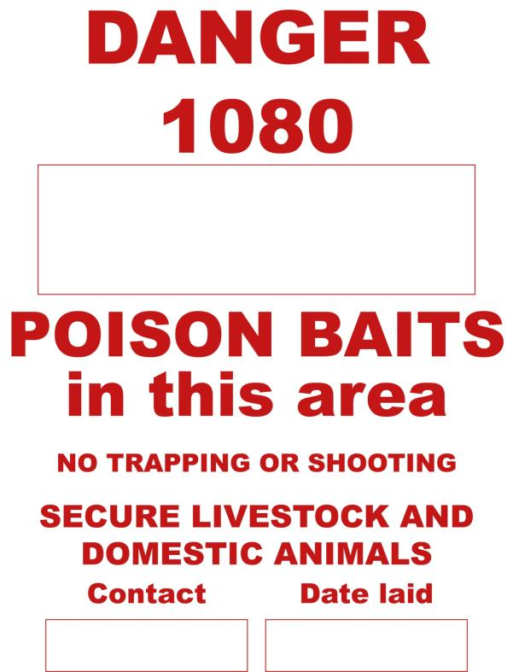
(Insert pest species here; for example FOXES)
(insert phone number here)
(insert date program starts here)

Appendix 6:1080 – Characteristics and use

The following information provides details on the characteristics of sodium fluoroacetate (1080) and its use in Western Australia
1080 is an extremely dangerous toxin with no effective antidote.Great care is required with its use

Sodium fluoroacetate (commonly known as ‘1080’) is used extensively as a vertebrate pesticide in Australia and New Zealand. With care, and provided the directions for use are followed, 1080 can be safely used to control vertebrate pests with few potential risks to non-target animals or the environment. In many instances, 1080-baiting programs are the only viable strategies available for broad-acre control of vertebrate pests.
1080 was introduced into Australian rabbit control programs in the early 1950s. Since then, it has been shown to be highly effective against a number of pest species, particularly foxes, rabbits, wild dogs and feral pigs. Well-planned and executed 1080-baiting programs usually achieve rapid, high-level population knockdowns.
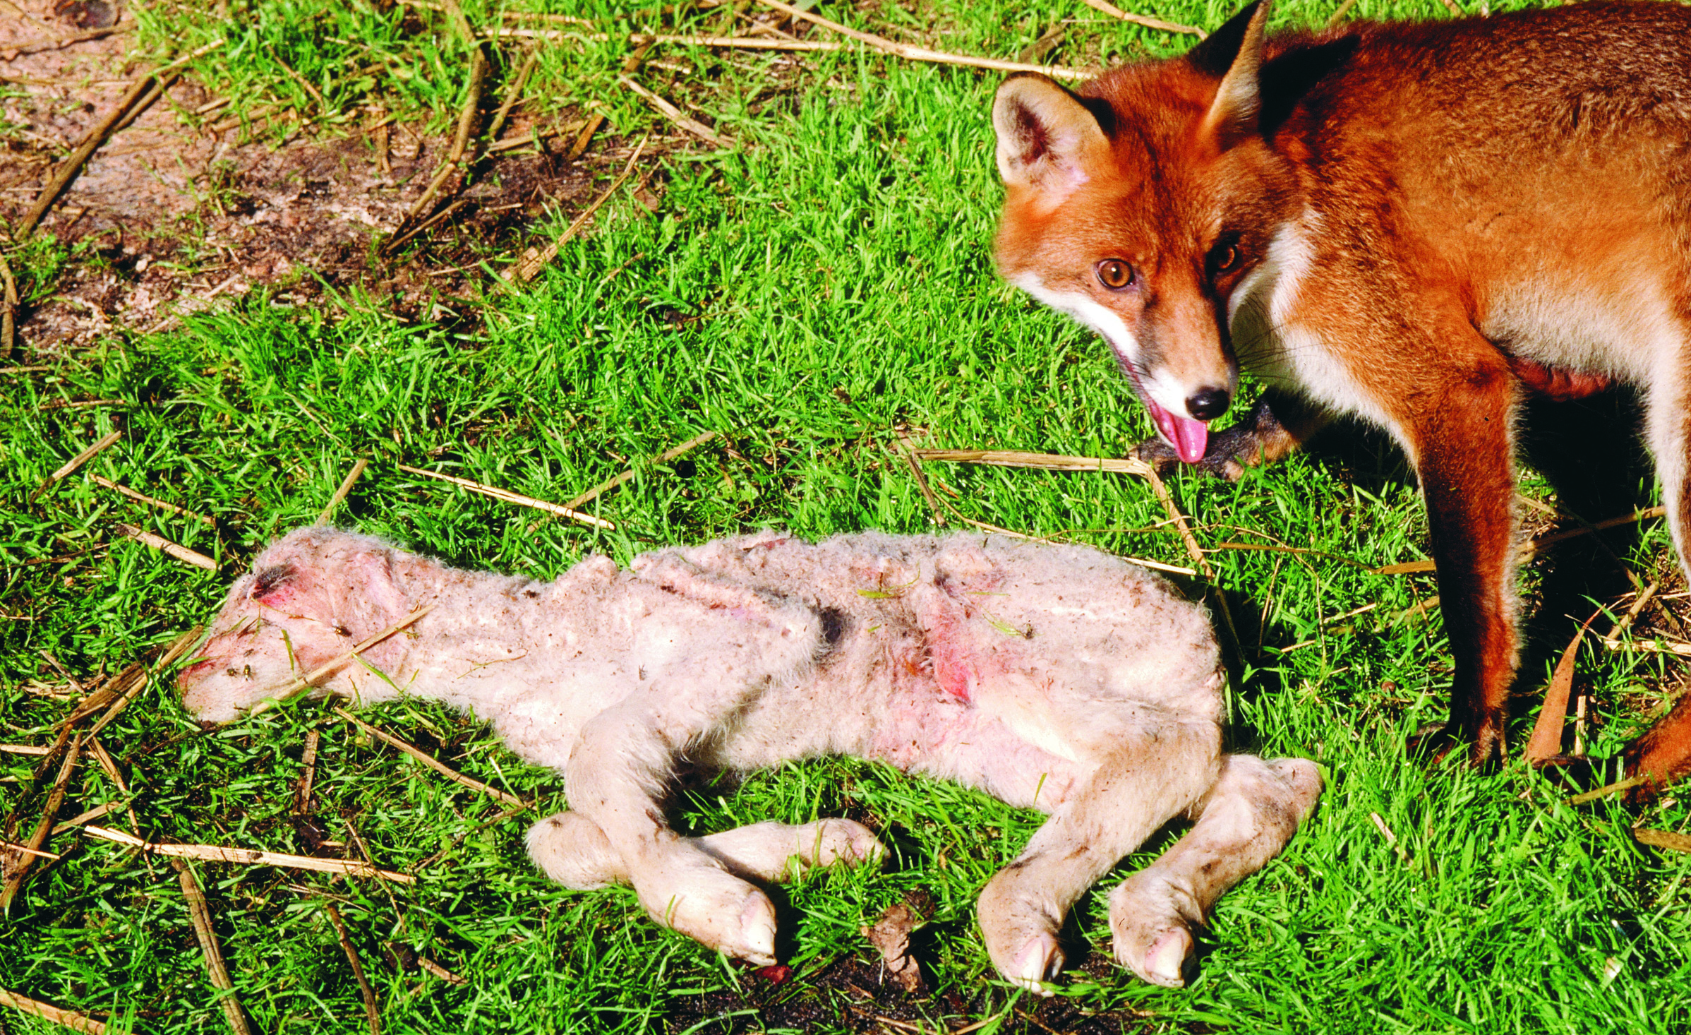
Fox predation can cause up to 30% losses of lamb
1080-baiting programs also have a long history of proven safety in Australia and New Zealand. In Western Australia, for example, there have been few reports of concerns with human safety, environmental persistence, accumulation in the food chain, or adverse impacts on non-target species.
Why control vertebrate pests?
Introduced vertebrates such as rabbits, foxes, wild dogs, and feral pigs have a significant and profound impact on agricultural production and biodiversity in Australia, including much of WA. These impacts include soil erosion, crop and pasture losses, the spread of weeds, degradation of on-farm bush remnants, damage to tree plantations, prevention of native plant regeneration and other habitat degradation (for example. destroying nests and nest sites), predation of domestic and native (such as rock wallabies, woylies, bandicoots, numbats, quolls and possums) animals, and the maiming of livestock (such as calves and lambs).

The impacts of these pests also include the potential to spread and maintain endemic and exotic animal diseases, including their implications for human health.
For example, feral pigs can act as reservoirs for a range of animal diseases, such as foot and mouth disease. Wild dogs can act as vectors for diseases that affect domestic dogs (e.g. distemper and mange). Until the disease-free status can be reconfirmed, the presence of any exotic disease in Australian livestock also has adverse implications for Australia’s livestock export trade.
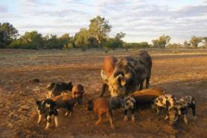
Vertebrate pests can be vectors for human diseases

In Australia, production losses and the cost of control to reduce these impacts, can range for $100 to $300 million per annum for rabbits, to around $230 million p.a. for foxes, $110 million p.a. for feral pigs, and $48 million p.a. for wild dogs with a further $10 million p.a. spent on maintaining several dingo/wild dog/vermin-proof fences. Consequently, a number of management strategies have been developed Australia-wide to reduce these impacts, and this includes judicious use of 1080 products.
What is 1080?
1080 concentrate is a highly water-soluble powder which is generally odourless and tasteless to humans. It is stable under normal conditions, but starts to break down at temperatures above 110o C and completely degrades at 200o C. The active ingredient of 1080 is sodium fluoroacetate, which is a natural plant product (see below). However, the 1080 used in baits is synthetically produced.
Mode of action
The ultimate toxicity of the active ingredient of 1080, fluoroacetate, arises from its effects on the energy-producing tricarboxylic acid cycle (TCA) in the mitochondria (mitochondria are the ‘powerhouse’ of cells). Consequently, affected animals are not able to meet their energy needs. However, fluoroacetate itself is not toxic as it must be converted within the animal (i.e. in the mitochondria) to a second substance, fluorocitrate, to exert its toxic effects. It is the fluorocitrate thus formed which actually interferes with the TCA cycle and the production of energy.
Because 1080 (fluoroacetate) needs to be absorbed and then converted to fluorocitrate, there is lag between the ingestion of 1080 and the appearance of signs of toxicity. In mammals, this lag-phase is generally between 0.5 and 3 hours, but it can be longer than this (e.g. up to 15 h). Animals receiving small sub-lethal doses of 1080 may show only mild signs, and they metabolise and excrete the 1080 within one (most mammals) to three (reptiles) days. They then recover.
The metabolic and physiological effects of 1080-poisoning are complex. The inhibition of the TCA cycle by fluorocitrate results in a cascade of events, including elevated citrate levels in plasma and tissues. This in turn results in neurological impairment and reduced calcium levels in poisoned animals. Adequate calcium is vital for normal heart function, and for normal communication between nerves in the spinal cord. However, keep in mind, that both the role of these neurotransmitters, and the consequences of 1080-induced neurological impairment, are also very complex and beyond the scope of this Bulletin.
Signs of poisoning
Visual signs of poisoning are generally neurological in carnivores, cardiac/respiratory in herbivores, and a mixture of neurological and cardiac signs in omnivores. However, because of the varied responses which can occur with 1080-intoxication, the classification of individual species into these groupings is often arbitrary.

Natural occurrence of 1080
Fluoroacetate, the active ingredient of 1080, occurs naturally in several toxic plants in Australia, South Africa, and South America. At least 40 such species occur in Australia, with most confined to the south-west of Western Australia. All of these species are legumes but most are from the genus Gastrolobium, with one Acacia, and two species of Nemcia. Some of the Gastrolobiums can produce considerable amounts of 1080 (e.g. G. bilobum, G. parviflorum; >2500 mg per kg dry weight of leaves). Fluoroacetate also occurs at very low concentrations in tea leaves, and guar gum, a common constituent of a variety of foodstuffs.
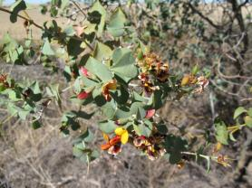
Prickly poison (Gastrolobiumspinosum) is native to Western Australia
Biodegradation
1080 is highly water soluble, and therefore readily leaches from most baits. However, mainly due to the activity of a number of fungi and bacteria (at least 24 different species) which can degrade 1080 into harmless by-products, accumulation in, or contamination of, soil or the environment does not occur. 1080 does not attain harmful levels and/or persist in waterways, even when quite high natural concentrations of fluoroacetate are present in the surrounding environment. Furthermore, as most 1080 is eliminated from living animals within three days, 1080 residues do not persist in meat, blood, the liver, or fat. (This is in contrast to the anticoagulant, brodifacoum and several other pesticides). Thus, bioaccumulation of fluoroacetate is very unlikely because biodegradation or elimination of fluoroacetate occurs at many levels in the food chain. This includes microorganisms, invertebrates, birds, mammals and reptiles.
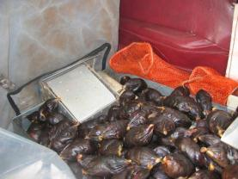
Baits ready to be distributed by plane
The longevity of 1080 in baits, or of the baits themselves, depends upon the prevailing weather conditions. In the presence of rain, baits may only remain toxic for a matter of days, particularly with the grain-based baits. In contrast, some baits used to control pest canids can remain toxic for several months under dry conditions. The loss and degradation of 1080 from baits and carcasses is mainly dependent upon leaching, and the activity of microorganisms. However, it is not only the longevity of baits and their active ingredient (i.e. 1080) which determines a potential risk profile. How quickly baits are taken, the rate of lay, and where baits are located all influence these assessments.
For safety reasons (e.g. restocking paddocks), however, it is best to assume that baits will remain toxic for at least 4 weeks, and end-users must make their own decisions based on the local conditions regarding restocking of baited paddocks. Some bait trails can be covered with soil to reduce any potential hazard.
Sensitivity of animals to 1080
Each major animal group (e.g. reptiles, mammals and birds) have differences in their metabolic rates which means that they also vary in their ability to convert fluoroacetate (1080) to fluorocitrate. Similar differences can also occur between the various Families within these groups. Consequently, there is often wide variation in the sensitivity of the different animal groups to 1080, and this is summarised below.
Canids (dogs and foxes) are among the most sensitive species to fluoroacetate. Herbivores and birds are less sensitive, and reptiles and amphibians are relatively insensitive to 1080.
Fish and other aquatic fauna (including many invertebrates) are relatively resistant to 1080, and lethal concentrations would not be achieved even under intensive, operational baiting programs. There is no evidence of detrimental impacts of 1080-baiting programs on individual invertebrates or their populations at the level of exposure that is likely to result from properly conducted baiting programs.
The acute toxicity of 1080 has been determined for over 240 species/populations of animals, including birds, mammals, reptiles and insects. However, the relative toxicity of 1080 can increase when some warm-blooded animals are exposed to temperature extremes outside of their normal body temperature range. 1080 can also have a chronic effect on animals, such as a temporary reduction in their fertility.
Sensitivity of introduced animals
Vertebrate pests such as wild dogs, foxes, rabbits, feral pigs and feral cats are introduced species and, consequently, are highly sensitive to 1080 (Table 1).
Table 1: LD50* of 1080 (mg/kg) for some introduced vertebrates
Species | LD50 (mg/kg)*
Dog | 0.11
Fox | 0.14
Rabbit | 0.42
Pig | 1-2
Cat | 0.40
Sheep | 0.49
Cow | 0.39
Horse | 0.41
Chicken | 7.70
Human | ~2

Most pets and domestic livestock are similarly quite sensitive to fluoroacetate (1080). Hence, they are also susceptible to 1080 baits. Domestic, and other dogs, are at risk both from eating 1080-baits, and through secondary poisoning. Secondary poisoning occurs when a dog feeds on the carcasses of animals (e.g. rabbits) killed by 1080 baits. These carcasses may remain toxic to introduced species (but not the more tolerant native species – see below) until theydecompose within 2-8 days. Secondary poisoning in this way also provides an added advantage in that some foxes will be killed by feeding on carcasses containing 1080. Livestock can also be killed if they are allowed to feed on 1080-poisoned grain baits used to control rabbits and/or feral pigs.
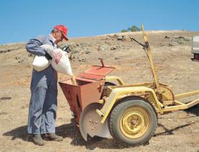
A bait layer being loaded for rabbit control

Sensitivity of native animals
Many native animals in Western Australia have co-evolved with fluoroacetate-bearing plants, and as a consequence, are often quite tolerant to 1080. That is, they can generally eat some of the toxic plants or animals containing 1080 (fluoroacetate) with little risk of being poisoned. However, in contrast, the same genus/species of animals in south-eastern Australia, where the toxic plants do not occur, are generally much more sensitive to 1080 (Table 2). Thus, the enhanced tolerance of our native animals makes 1080 a particularly useful and target specific toxin in WA. However, provided that best practice procedures are followed, enhanced tolerance to 1080 is not a prerequisite for safe and effective baiting programs.
Target specificity
The target specificity of 1080 baits is enhanced by the increased tolerance to 1080 of many of WA’s native fauna. However, the specificity of any poison bait, including 1080 products, is determined by a number factors including the sensitivity of target and non-target species to the active ingredient, the body mass of non-target animals relative to that of the target-species, the bait medium used, the hardness of the bait and where the toxin is located, whether non-target animals are exposed to the toxic baits or poisoned animals and, if so, whether these are acceptable food items, and the timing of baiting programs.
Properly conducted baiting programs (i.e. in accordance with the label directions) provide safe and effective control options. Shallow burial of baits under ground litter, or the tethering of baits, can further reduce potential risks to non-target species.
Table 2: LD50 of 1080 (mg/kg) for some native Australian animals
Species | LD50 (mg/kg)
Bobtail skink
Western Australia | >800
South Australia | 201
Rosenberg’s goanna
Western Australia | 235
South Australia | 38
Brushtail possum
Western Australia | 118
South Australia | 0.64-0.84
Western grey kangaroo | 47
Eastern grey kangaroo | 0.29
Banded hare-wallaby | 106
Chuditch/Western quoll | 7.1
Red-tail phascogale | 16.5
Emu | 96
Malleefowl | 106
Bronzewing pigeon | 38
Western rosella | 71
Brown falcon | ~30
Barn owl | ~22

Amounts of 1080 used in New Zealand and Australia
New Zealand is the greatest user of 1080 concentrate, using up to four tonnes of powder per year. In contrast, only around 200 kg of 1080 powder are used in Australian pest control programs each year. 1080 baits have been used in New Zealand since the 1950s, primarily for aerial baiting of possums introduced from eastern Australia, and for the control of rabbits. Possum control is aimed at protecting biodiversity and helps to reduce the spread of bovine Tb. New Zealand sowing rates for aerial operations are 3–5 kg/ha, which equates to 4.5–7.5 g 1080/ha. This compares to around 0.00015 g 1080/ha for many fox baiting programs in Western Australia. Interestingly, areas with fluoroacetate-bearing plants can have up to 550 g of fluoroacetate per ha and yet, due to its degradation by microbes, fluoroacetate does not persist in these environments.
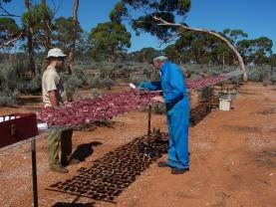
Inspecting and drying field –prepared wild dog baits

How does 1080 compare to alternatives?
As yet there are no alternative broad-scale methods for effectively and efficiently reducing the numbers and impact of vertebrate pests across Australia. Some of the possible additional options considered are discussed below.
Immunosterility
Fertility control of pest species is an attractive option as it focuses on decreasing birth rate rather than increasing death rate as do lethal control options. The possibility of developing target-specific, naturally disseminated, anti-fertility, genetically-modified agents has been considered for rabbits, house mice, foxes, and introduced (New Zealand) brushtail possums. However, despite a conservatively estimated $80AUD million research effort spanning three Cooperative Research Centres over approximately 15 years, the technical challenges have proven too great with current technology, and disseminating or bait delivered fertility control could not be practically developed for any pest species.
Strychnine
Strychnine is not target-specific as most animals are equally highly sensitive to this toxin. Strychnine also has a high environmental persistence. Strychnine is not registered for use in predator baits in Western Australia, but it can be used on trap-jaws to help ensure a humane death when trapping wild dogs. It is also used on grain to control emus because of their high tolerance to 1080 (Table 2).
Shooting, trapping, fumigation and warren destruction
These are all viable techniques when pest control needs to be undertaken at a localised level, although they too can have potential risks associated with their use (e.g. fumigation can kill native animals, warren ripping may destroy native vegetation). Because of the associated cost, and/or the logistics involved, these methods are generally impractical and unsuitable for broad-acre pest control programs.
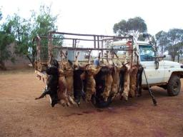
Trapping can be an useful option for wild dog control

Use of 1080 in other countries
A few other countries also use 1080. These include New Zealand, Mexico, Japan, Korea, Israel, and very restricted use in the United States (sheep-coyote collars). 1080 is not approved in many other countries because of concerns regarding potential human, and other off-target, poisoning.
Safe use of 1080 through regulation
1080 use in Australia is closely regulated by Commonwealth (Australian Pesticides and Veterinary Medicines Authority) and State (Department of Health) government agencies. Supply of 1080 products is strictly regulated, and clear guidelines are provided to govern its use in all States.
In Western Australia, additional State regulations also apply via the Poisons Act 1964, the Poisons Regulations 1965, the Health (Pesticides) Regulations 1956, and the Code of Practice for the Safe Use and Management of 1080 in Western Australia. The Dangerous Goods Safety Act 2004 provides general regulation for the storage, handling and transportation of 1080, and 1080 products.
These restrictions mean that:
- 1080 is not readily available to the general public.
- Authorisation is required before anyone can obtain 1080 baits.
- A Risk Assessment is undertaken before any authorisation is given.
- Training requirements are stipulated, and must be met.
- Reporting of incidents is mandatory.
This process is overseen by the Western Australian Department of Health.

Further reading
Department of Health, Western Australia, Code of Practice for the Safe Use and Management of 1080 in Western Australia.
King D. R. (1990). 1080 and Australian fauna.Agriculture Protection Board Technical Series No 8, 27 pp.
King D. R. and Kinnear J. K. (1991). 1080: the toxic paradox. Landscope 6 (4), 14-19.
McLeod R. (2004). Counting the Cost: Impact of Invasive Animals in Australia 2004. Cooperative Research Centre for Pest Animal Control, Canberra, Australia
Twigg L. E. and King D. R. (1991).

